Assignment -6

**Question** - Clone game of life in master and build, then create custom image for Apache tomcat using dockerfile and deploy war file in tomcat container.

**Step -1 :** configure Jenkins master –

1. Yum update -y
2. Install java 8.
3. Install Apache tomcat, start tomcat – deploy Jenkins in tomcat webapps.
4. Install maven. Set environment variable.

**Step-2 :**  Jenkins console :

1. 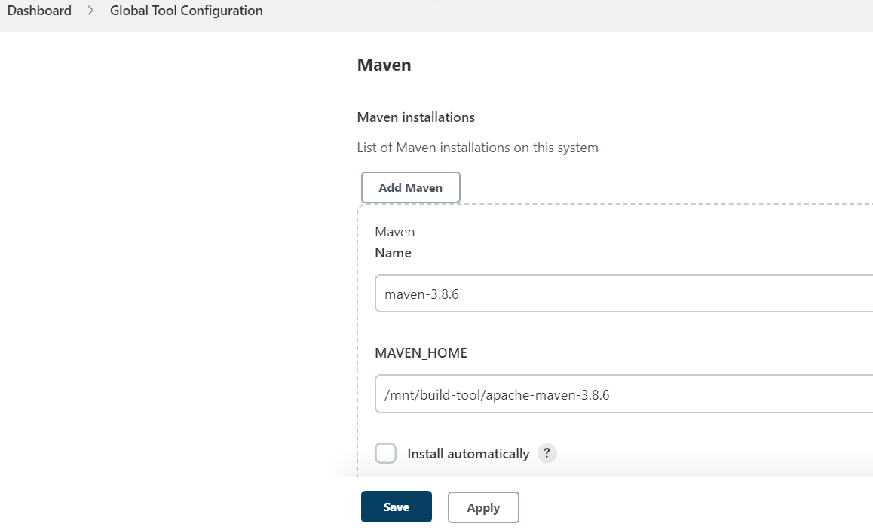Setup maven tool in global tool configuration.
2. Set url of Jenkins
3. 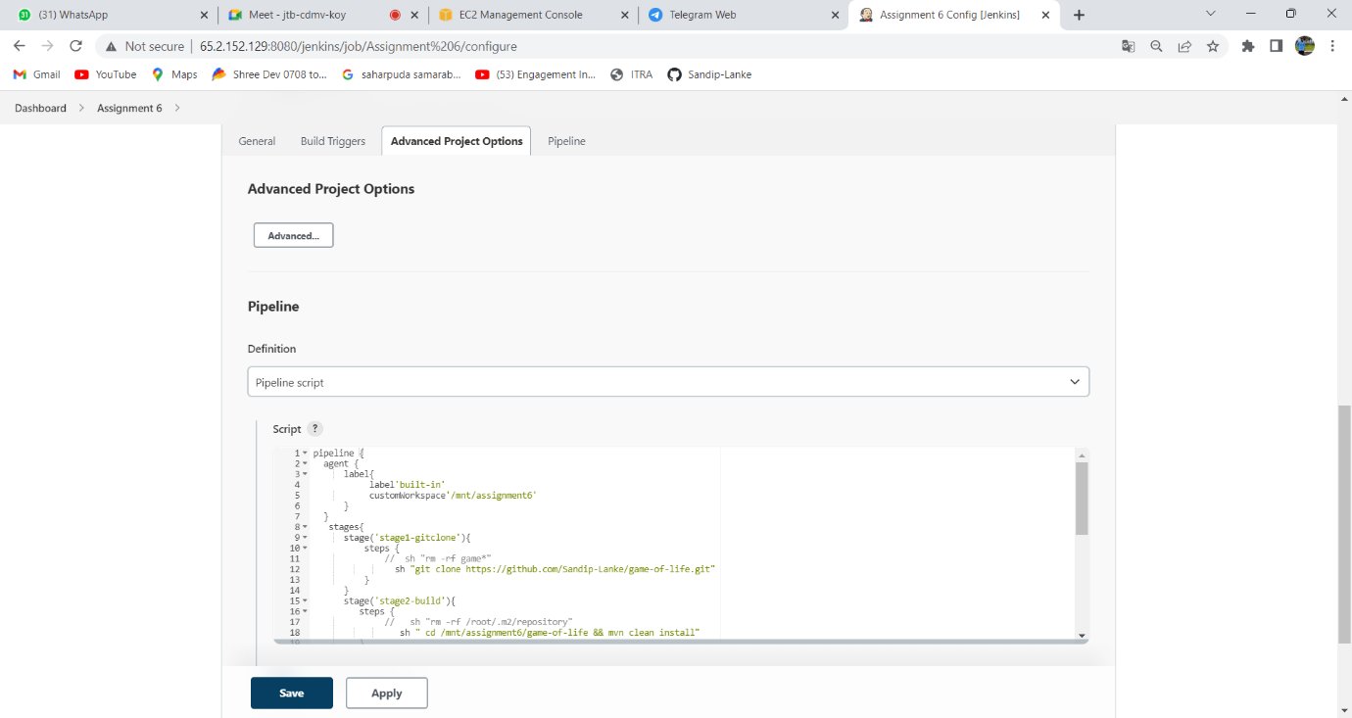Create job -> select pipeline job 🡪

**Step-3** : create docker file in your Jenkins master instance.

1. cd /mnt/assignment6/docker
2. Dockerfile :

***FROM tomcat:9***

***COPY gameoflife.war /usr/local/tomcat/webapps/***

***EXPOSE 8080***

***CMD ["catalina.sh", "run"]***

**Step-4 :** Pipeline script

pipeline {

agent {

label{

label'built-in'

customWorkspace'/mnt/assignment6'

}

}

stages{

stage('stage1-gitclone'){

steps {

sh "rm -rf game*"

sh "git clone https://github.com/Sandip-Lanke/game-of-life.git"

}

}

stage('stage2-build'){

steps {

sh "rm -rf /root/.m2/repository"

sh " cd /mnt/assignment6/game-of-life && mvn clean install"

}

}

stage('stage3-copyWAR'){

steps{

sh "cp -r /mnt/assignment6/game-of-life/gameoflife-web/target/gameoflife.war /mnt/assignment6/docker/"

sh "chmod -R 777 /mnt/assignment6/docker/gameoflife.war"

}

}

stage('stage4-Docker'){

steps {

dir('/mnt/assignment6/docker/')

{

sh " yum install docker -y"

sh "systemctl start docker"

// sh "docker stop tomcat-container"

// sh "docker system prune -af"

sh "docker build -t mytomcat:1.0 ."

sh "docker run --name tomcat-container -itdp 8090:8080 mytomcat:1.0"

}

}

}

}

}

Step 5: open port 8090 in SG

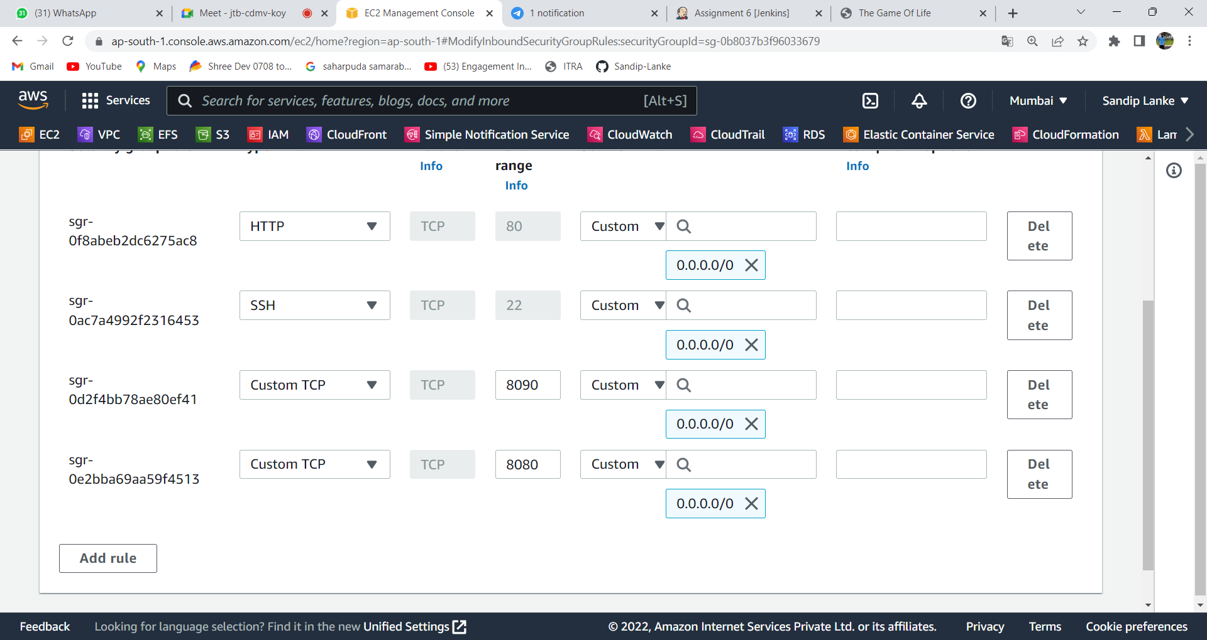

Step 6: Build the project and check console output and verify the result.

